

Semester Two Examination, 2021

Question/Answer booklet

SPECIALIST MATHEMATICS
UNITs 3 & 4

Section One:

Calculator-free

Your Name

Your Teacher’s Name

Time allowed for this section
Reading time before commencing work: five minutes
Working time: fifty minutes

Materials required/recommended for this section
To be provided by the supervisor
This Question/Answer booklet
Formula sheet

To be provided by the candidate
Standard items: pens (blue/black preferred), pencils (including coloured), sharpener, correction fluid/tape, eraser, ruler, highlighters

Special items: nil

Important note to candidates
No other items may be taken into the examination room. It is your responsibility to ensure that you do not have any unauthorised material. If you have any unauthorised material with you, hand it to the supervisor before reading any further.
Question | Mark | Max | Question | Mark | Max
1 |  |  | 5
2 |  |  | 6
3 |  |  | 7
4 |  |  | 8

Structure of this paper

Section | Number of questions available | Number of questions to be answered | Working time (minutes) | Marks available | Percentage of examination
Section One:  Calculator-free | 8 | 8 | 50 | 51 | 35
Section Two:  Calculator-assumed | 13 | 13 | 100 | 101 | 65
 |  |  |  | Total | 100

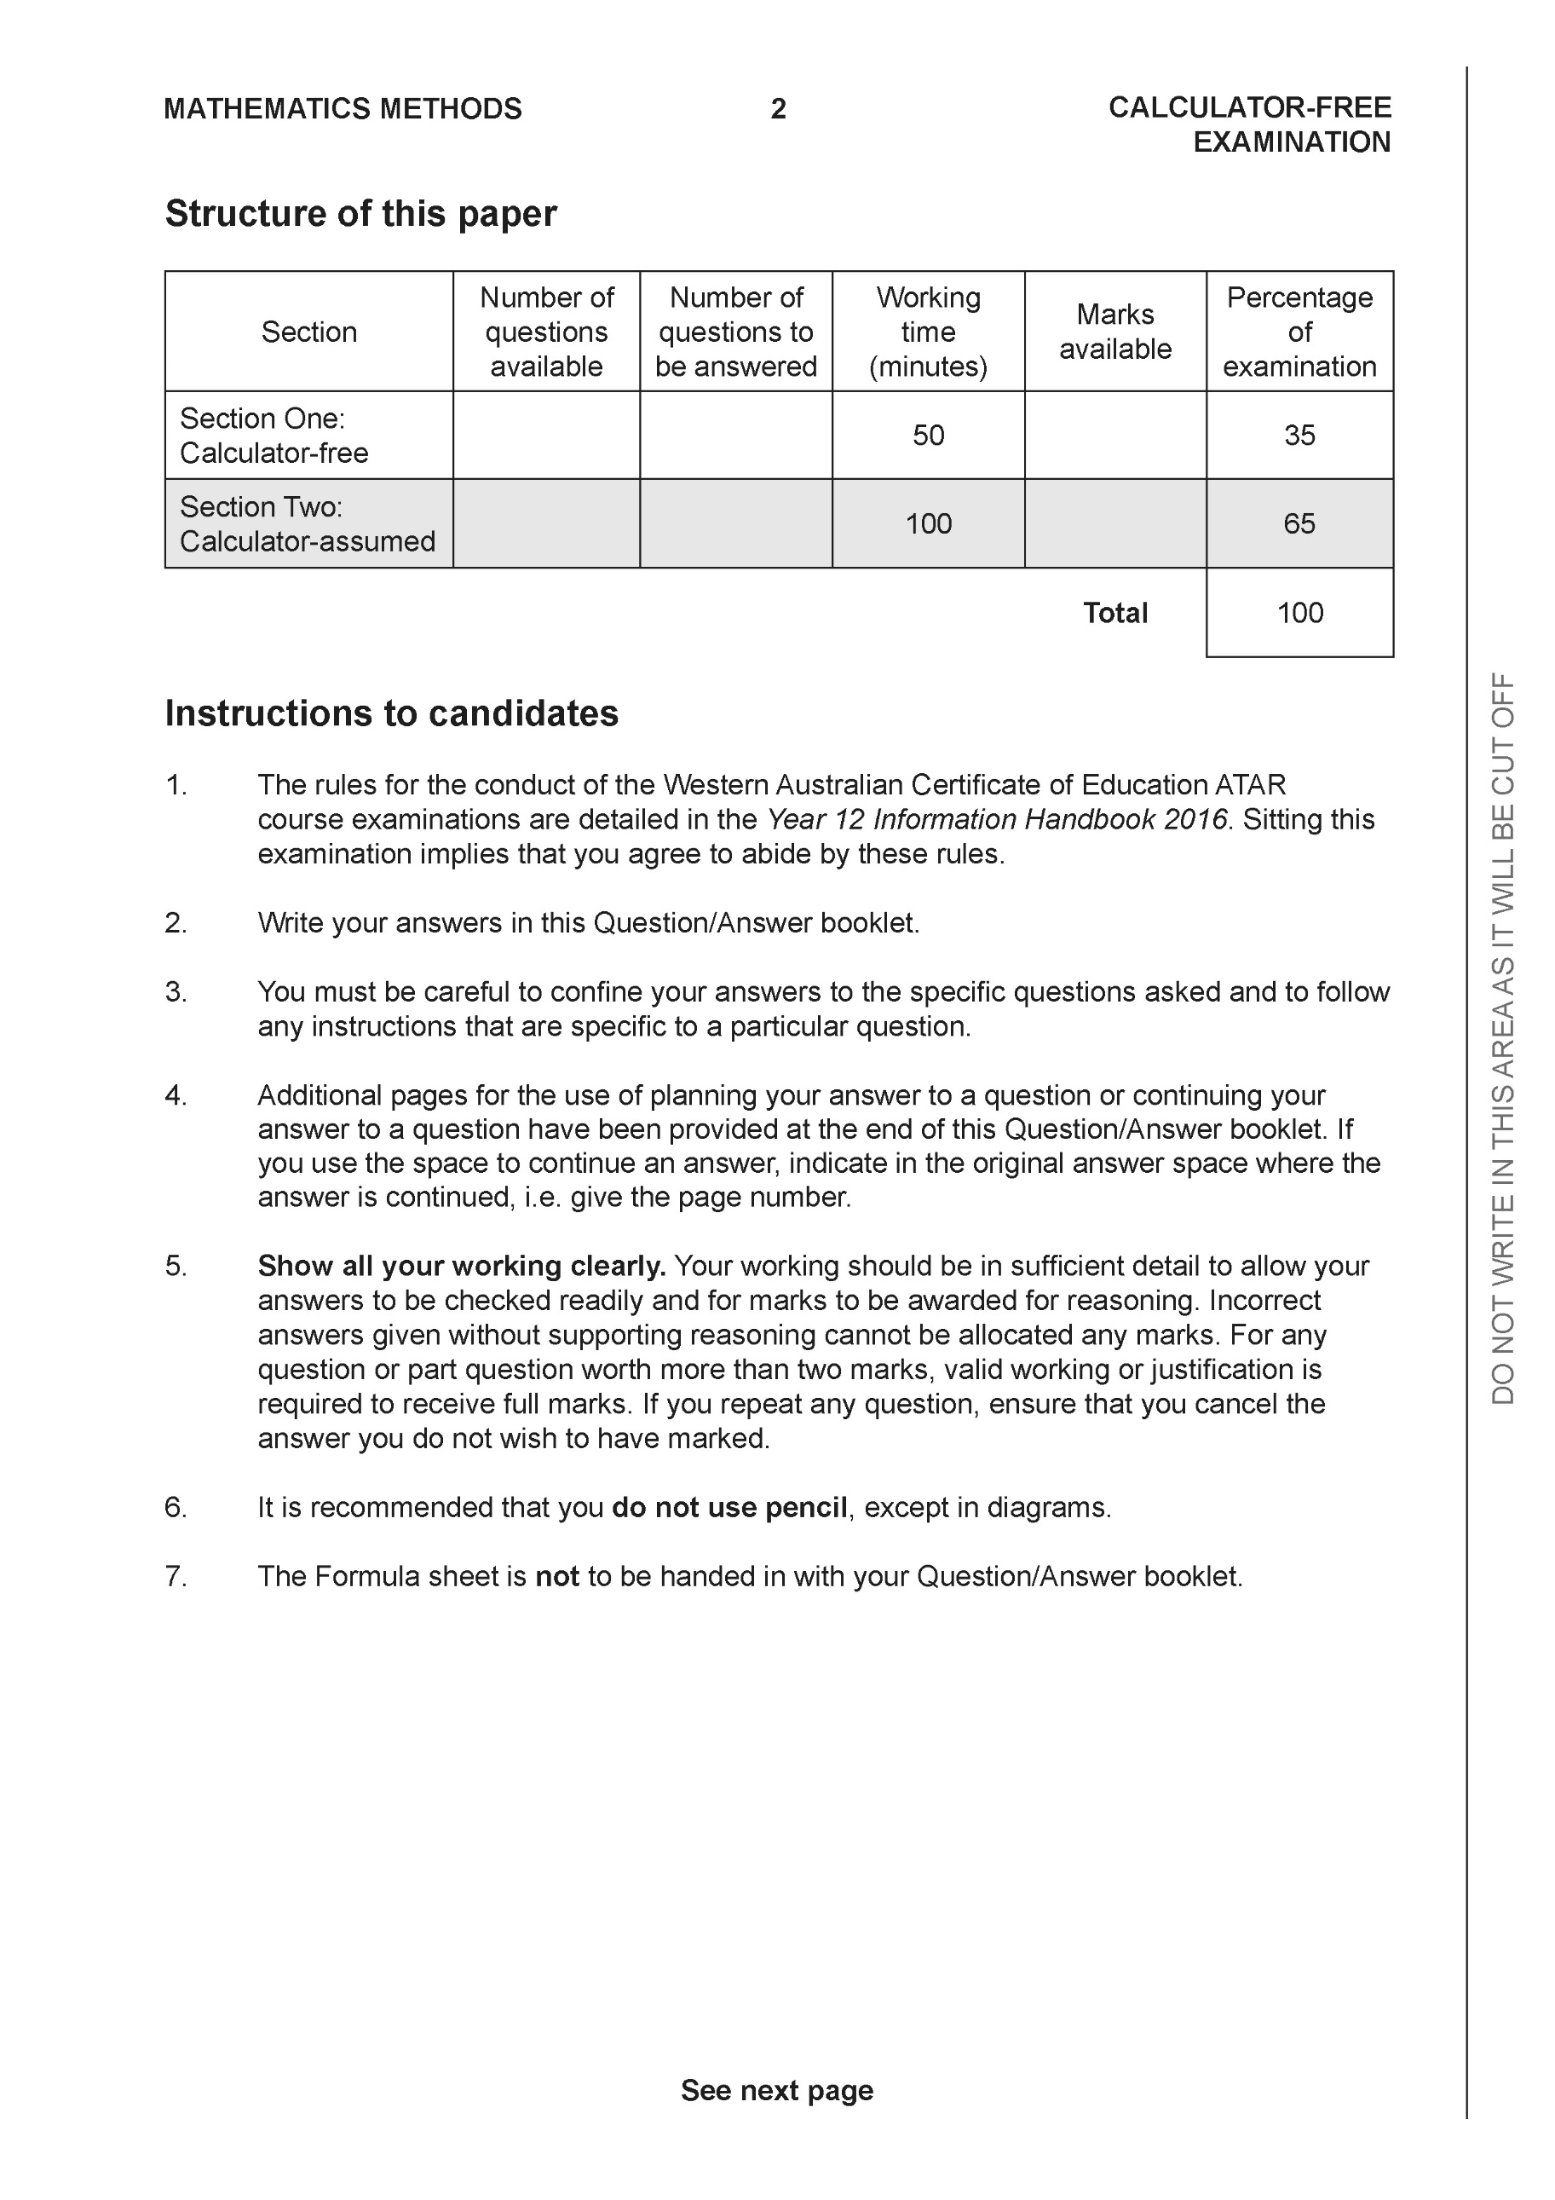

Section One: Calculator-free (50 Marks)

This section has eight (8) questions. Answer all questions. Write your answers in the spaces provided.

Spare pages are included at the end of this booklet. They can be used for planning your responses and/or as additional space if required to continue an answer.
● Planning: If you use the spare pages for planning, indicate this clearly at the top of the page.
● Continuing an answer: If you need to use the space to continue an answer, indicate in the original answer space where the answer is continued, i.e. give the page number. Fill in the number of the question that you are continuing to answer at the top of the page.

Working time: 50 minutes.

Question 1 (4 marks)

Evaluate

Solution
Specific behaviours
P uses double angle formula
P integrates all terms
P evaluates upper limit
P states exact value

Question 2 (6 marks)

Consider a plane that contains the following points .

- Determine a normal vector to the plane. (4 marks)

Solution
Specific behaviours
P determines one vector in plane
P determines two vectors in plane
P uses cross product
P gives a normal vector

- Determine a cartesian equation for the plane. (2 marks)

Solution
Specific behaviours
P determines vector equation
P states cartesian equation

Question 3 (6 marks)

Sketch the function on the axes below, labelling important features.

Solution
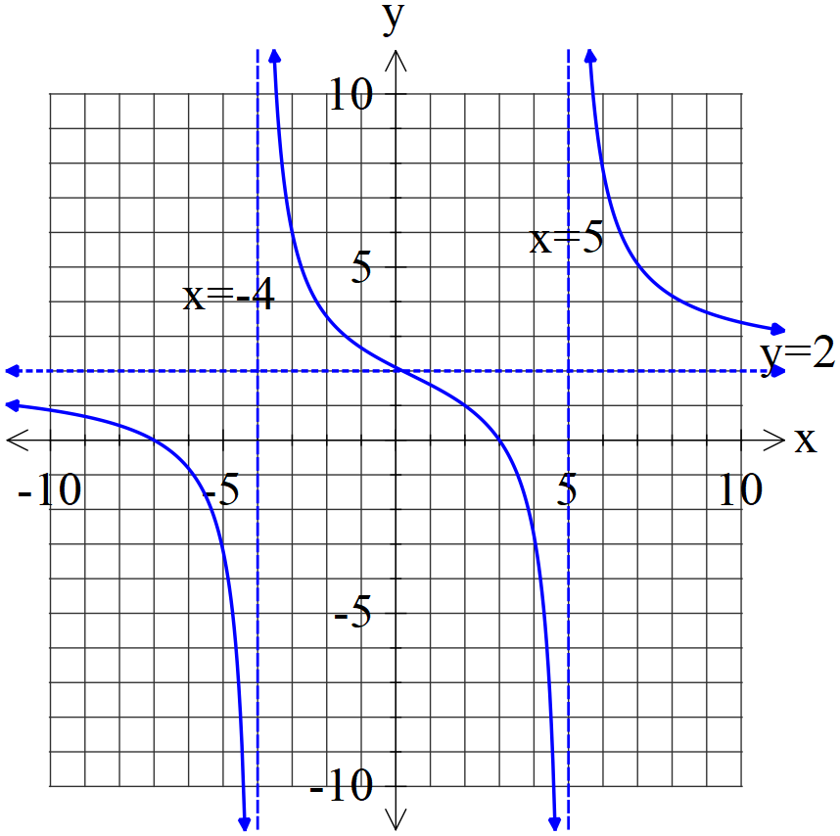

Specific behaviours
P vertical asymptotes dotted and labelled with equation
P horizontal asymptote dotted and labelled with equation
P approx. y intercept correct
P both x intercepts correct exactly
P shape correct between vertical asymptotes
Poverall shape is correct for all x values

Question 4 (6 marks)

- Solve the following system of linear equations. (3 marks)

Solution
Specific behaviours
P eliminates one variable in two equations
P eliminates two variables in one equation
P solves for all variables

- Solve for all possible values of for the system below for each of the following scenarios. (3 marks)

- Unique solution.
- Infinite solutions
- No solutions.

Solution
i)
ii)
iii)

Specific behaviours
P eliminates two variables
P states values for uniqueness
P states values for infinite and no solns

Question 5 (6 marks)
Consider the function drawn below.
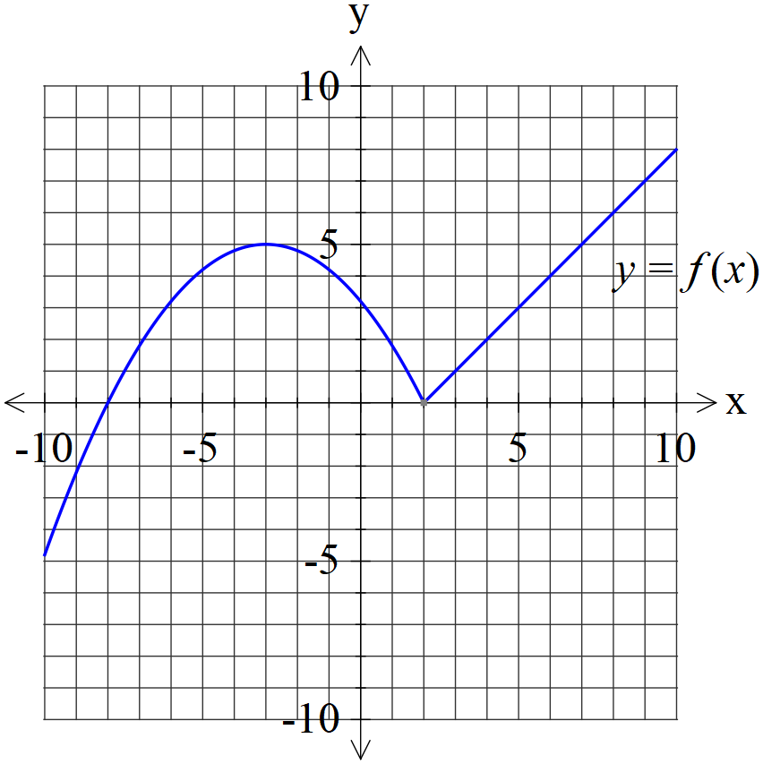
- Plot on the axes below. (2 marks)

Solution
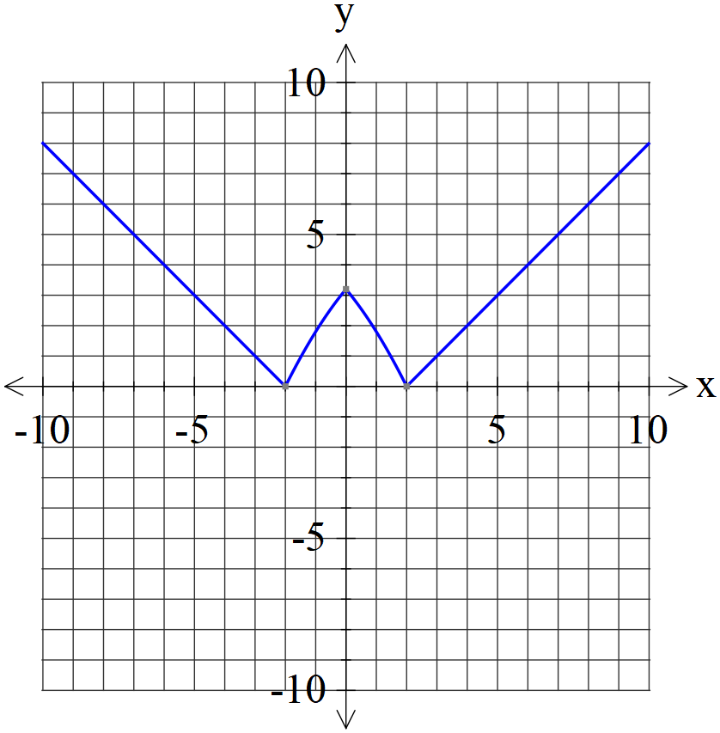

Specific behaviours
P reflects right side
P x & y intercepts correct

- Plot on the axes below. (4 marks)

Solution
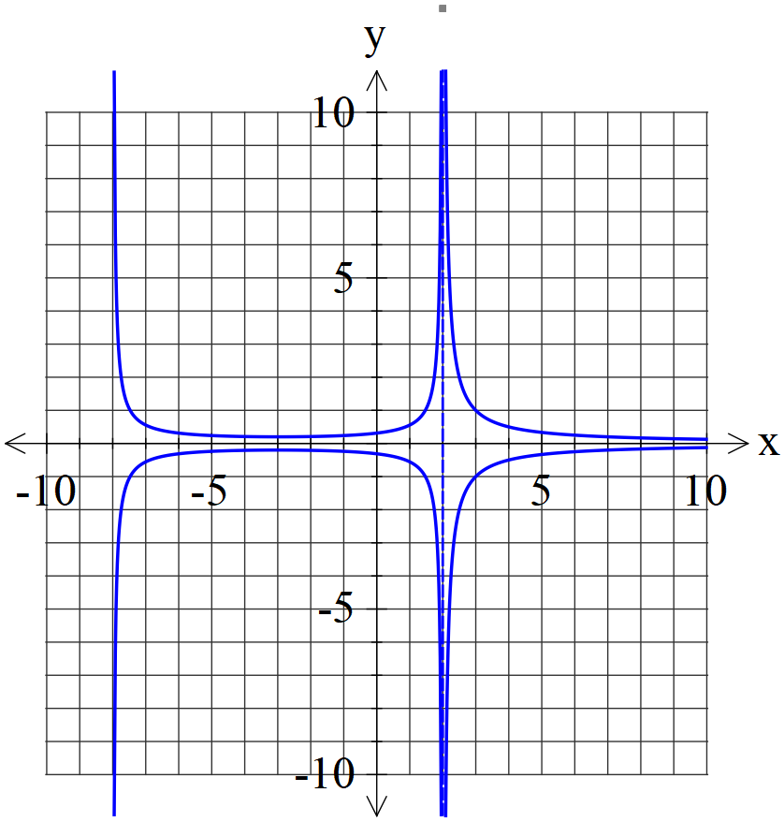

Specific behaviours
P both asymptotes for y>0
P approx y intercept and turning pt for y>0
P shape for y>0
P shape for y<0

Question 6 (9 marks)

Consider the function with domain .
Let .
- Determine the domain and range of . (2 marks)

Solution
Specific behaviours
P domain
P range

- By using implicit differentiation show that is of the form where is a constant. (4 marks)

Solution
(Note: accept )

Specific behaviours
P replaces x & y
P implicit diff wrt x both sides
P uses Pythagorean identity
P expresses in required form

- Evaluate with substitution . (3 marks)

Solution
Specific behaviours
P changes limits
P simplifies in terms of u
P integrates and states final result

Question 7 (7 marks)

- Given that with constants. Solve for . (4 marks)

Solution
Specific behaviours
P sets up am equation with all constants
P shows working on solving for 2 constants
P solves for 3 constants
P solves for 4 constants

- Hence determine an expression for . (3 marks)

Solution
Specific behaviours
P integrates one term
P integrates two terms
P integrates all terms and adds a constant

Question 8 (7 marks)

Evaluate the following integrals.
- (3 marks)

Solution
Specific behaviours
P uses a change of variable
P expresses integral in terms of new variable and integrates
P changes limits and subs into final expression (no need to simplify)

- (4 marks)
Solution
Specific behaviours
P uses u=tanx
P uses partial fractions and shows working for constants
P integrates wrt new variable
P expresses in terms of x (unsimplified)
Note: Follow through for last two marks only if partial fractions used

Additional working space
Question number:

Additional working space
Question number:

Additional working space
Question number:

Acknowledgements

